Code formatting and Checkstyle Plugin

Code formatting is an important part of the development workflow and ensures both a readable and consistent code base. CLE uses [checkstyle](https://checkstyle.sourceforge.io/) to manage code formatting in local development environments and as part of the automated build pipeline.

Checkstyle for Local Development

A plugin is available for IntelliJ that allows developers to apply a consistent checkstyle format to their code locally.

**Install Checkstyle Plugin**

1. Go to **Settings → Plugins**, select **Marketplace**, and search for the Checkstyle-IDEA plugin.

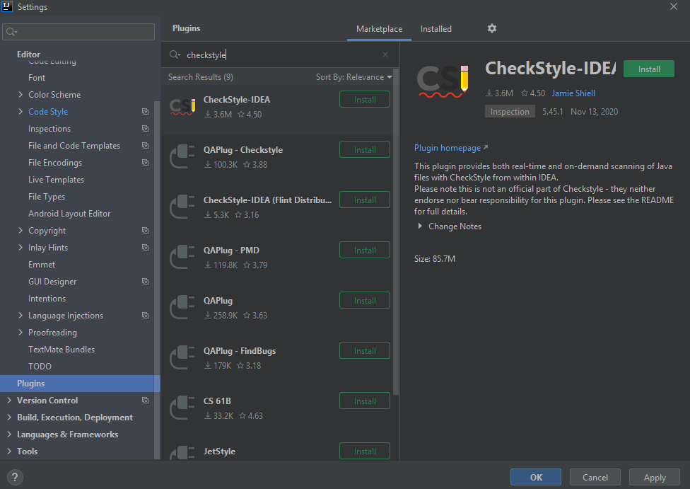

1. Install the plugin, then **restart IDEA.**

### Configure Checkstyle Plugin

Go to **Editor (Ctrl + Alt + S) → Code style**, **Java** and select **Import Scheme →** **Checkstyle Configuration**.

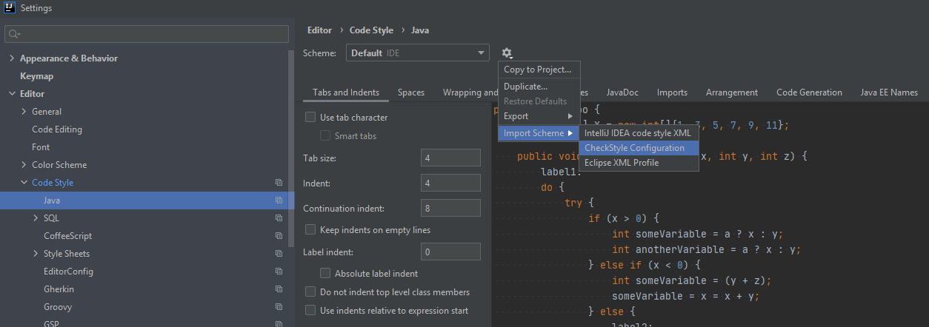

Select the [checkstyle.xml](https://dev.azure.com/cle-automation/CLESpringBootParent/_git/CLESpringBootParent?version=GBdevelopment&path=%2Fsrc%2Fmain%2Fresources%2Fcheckstyle.xml) configuration file from **<service>/src/main/resources**.

Note: Its important you use this exact file and not one of the various flavors found online. Using this specific file ensures that you are using the same formatting rules as the automated build process. It also ensures that the format of the file aligns with the version of checkstyle being used by the checkstyle maven plugin.

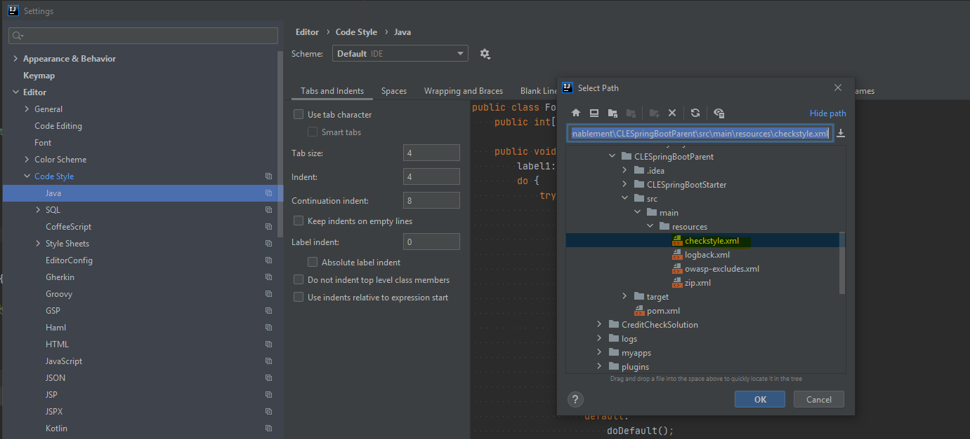

Finally, click **Apply** and **OK**.

## Checkstyle in the Maven Build

Checkstyle runs as part of the maven build, applying the rules from checkstyle.xml against all Java files in src/main/java and src/test/java. Checkstyle violations result in a build failure with the offending classes and lines highlighted in the console.

Assuming your project has the above poorly formatted class, running a maven build would highlight these issues and fail the build.

|  |
| --- |
| <plugin>  <groupId>org.apache.maven.plugins</groupId>  <artifactId>maven-checkstyle-plugin</artifactId>  <version>${checkstyle.version}</version>  <configuration>  <configLocation>src/main/resources/checkstyle.xml</configLocation>  <consoleOutput>true</consoleOutput>  <encoding>UTF-8</encoding>  <failsOnError>true</failsOnError>  <includeTestSourceDirectory>false</includeTestSourceDirectory>  <outputDirectory>${project.build.directory}/checkstyle</outputDirectory>  <violationSeverity>warning</violationSeverity>  <excludes>**/generated/**/*</excludes>  </configuration>  <dependencies>  <dependency>  <groupId>com.puppycrawl.tools</groupId>  <artifactId>checkstyle</artifactId>  <version>${puppycrawltools.version}</version>  </dependency>  </dependencies>  <executions>  <execution>  <goals>  <goal>check</goal>  </goals>  <id>checkstyle</id>  <phase>initialize</phase>  </execution>  </executions>  <inherited>true</inherited>  </plugin> |